**SYNOPSIS**

**ON**

**Weather Forecasting App**

**BY**

**Aakanksha Avadhut Mujumdar**

**SAVITRIBAI PHULE PUNE UNIVERSITY**

**MASTER OF COMPUTER APPLICATION**

**Under the guidance of**

**Prof. Harini Pawar**

**Dr. D.Y. Patil Centre for Management & Research**

**Newale Vasti, Chikhali, Pune-412114**

**Year 2023-2024**

**INTRODUCTION**

Weather forecasting is the application of science and technology to predict the conditions of the atmosphere for a given location and time. Weather forecasts are made by collecting quantitative data about the current state of the atmosphere at a given place and using meteorology to project how the atmosphere will change. The role of Technology has been remarkable in the field of weather forecasting. Weather data is not only necessary for researchers or scientists, ordinary people can be benefitted from it as well. People nowadays are feeling the necessity of weather data as well. There are a variety of weather mobile apps in Google Play and the App store.

1. **Real-Time Weather Data:** WeatherNow integrates with a powerful weather API to fetch real-time weather information for any location around the world. Get access to current weather conditions, forecasts, temperature, humidity, wind speed, and more.
2. **Registration and Login with Firebase:** We prioritize the security of your data. WeatherNow employs Firebase for user authentication and management. You can register a new account, log in securely.

**OBJECTIVES**

1. **Accurate Weather Information**: Provide up-to-date and accurate weather data to users by integrating with a reliable weather data source or API.
2. **Weather Forecast**: Offer current weather conditions and forecasts for the next few days, including temperature, precipitation, wind speed, and humidity.
3. **Multiple Locations**: Allow users to switch between multiple locations.
4. **Performance Optimization**: Ensure the app runs smoothly and responds quickly, even on older or less powerful devices.

**REQUIREMENTS**

* **Hardware Requirements :**
* Processor 🡺 Intel Core i3
* Hard Disk 🡺 512GB
* RAM 🡺 4GB
* **Software Requirements :**
* Operating System 🡺 Windows 7 or later, macOS, Linux
* Tools/ IDE 🡺 Android Studio

**FRONTEND**

1. **Java Language:** Android app development primarily relies on Java, a versatile, platform-independent programming language known for its portability and ease of use.
2. **Android Studio:** Developers use Android Studio as the official integrated development environment (IDE) for creating Android apps. It offers a suite of tools, including code editors and layout designers, to simplify the development process.

1. **XML Layouts and Views:** The app's user interface is defined using XML layout files, which include various views (e.g., buttons, text fields, images). XML files are linked to Java code to manage user interactions.
2. **Manifest File:** The AndroidManifest.xml file provides essential information about the app, such as its name, package name, permissions, and the activities it contains. This file is necessary for the Android system to identify and launch the app.

**BACKEND**

**API (Application Programming Interface):** An API, or Application Programming Interface, is a set of rules and protocols that allows different software applications to communicate and interact with each other. APIs are crucial for enabling the integration of different systems, services, and applications. They serve as intermediaries that allow developers to harness the functionality of other software without needing to understand the intricacies of how that software works internally.

**Firebase:** Firebase is a comprehensive mobile and web application development platform provided by Google. It offers a set of tools and services that help developers build high-quality apps more efficiently.

Firebase simplifies many aspects of app development by offering a scalable, fully managed infrastructure for backend services. Developers can focus on building features and user experiences while Firebase handles the underlying infrastructure and server-side logic. It's a popular choice for startups and developers looking to accelerate app development without sacrificing quality and security.

**MODELS NAME:**

1. **Registration 🡺** Email, Password
2. **Login 🡺** Email, Password
3. **Weather API 🡺**

* **Location 🡺** Name , Latitude, Longitude
* **Current 🡺** Temperature

**Condition 🡺** Text, Icon

* **Forecast 🡺**

**Forecastday 🡺** Date

* **Hour 🡺** Time, Temperature , is_day

**Condition 🡺** Text, Icon, Wind

**CLASS DIAGRAM**

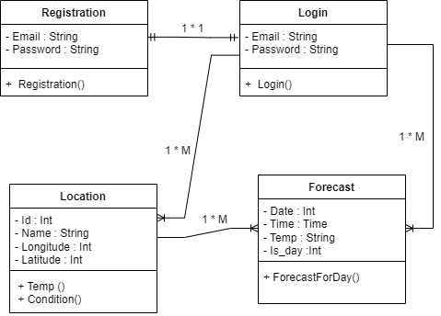

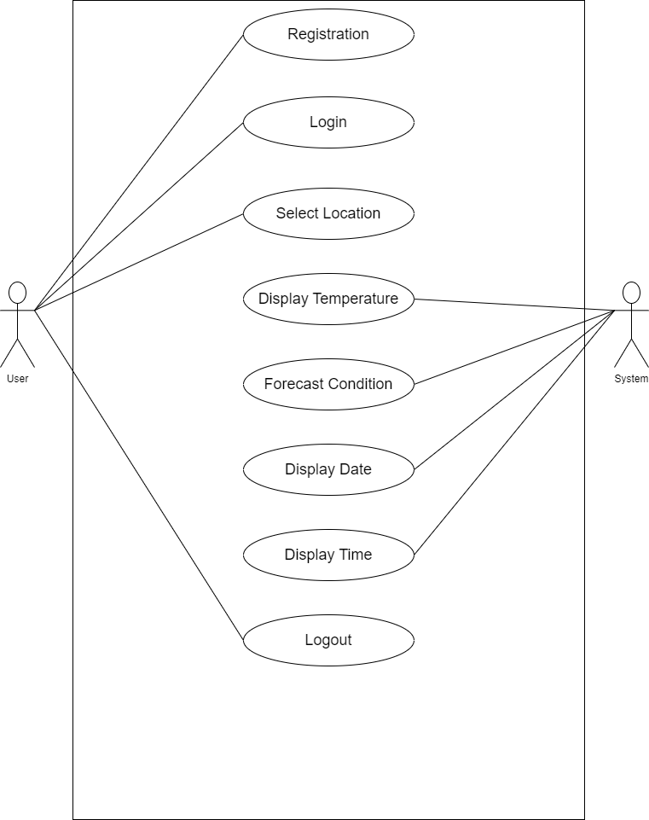**GLOBAL USE CASE DIAGRAM**

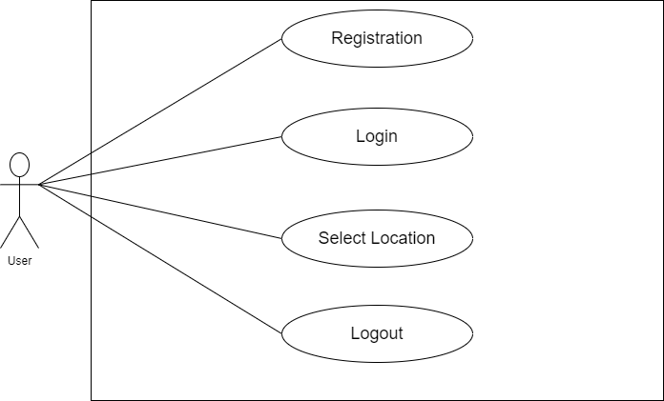**INDIVIDUAL USE CASE DIAGRAM**

